Atitit diaryindex s2018

Atitit s2018 2018sfx diary log events memorabilia 大事记 日记 v6 t33 .docx

C:\Users\zhoufeiyue\Documents\l1 diary s2018 v3 t33

目录

1.1. S1 diary 1

1.2. Atitit diary s2sfx s2018sfx 2018sfx outline n detail v s429.docx 2

1.3. Atitit diary s3sfx s2018sfx 2018sfx outline n detail v4 s429.docx 2

1.4. Atitit diary s4sfx s2018sfx 2018sfx outline n detail vs429.docx 2

1.5. Atitit diary s5sfx s2018sfx 2018sfx outline n detail v5 t33 .docx 3

1.6. Atitit diary s6sfx s2018sfx 2018sfx outline n detail v1 s620 .docx 3

1.7. Atitit diary s7sfx s2018sfx 2018sfx outline n detail v3 s731 .docx 3

1.8. Atitit diary s8sfx s2018sfx 2018sfx outline n detail v3 s98 .docx 4

1.9. Atitit diary s9sfx s2018sfx 2018sfx outline n detail v2 s09.docx 4

1.10. Atitit diary s0sfx s2018sfx 2018sfx outline n detail v1 sa5.docx 5

1.11. Atitit diary sasfx s2018sfx 2018sfx outline n detail v1 sa5.docx 5

1.12. Atitit diary sbsfx s2018sfx 2018sfx outline n detail v1 sb28.docx 5

Atitit diary s2sfx s2018sfx 2018sfx outline n detail v s429.docx

Atitit diary s3sfx s2018sfx 2018sfx outline n detail v4 s429.docx

Atitit diary s4sfx s2018sfx 2018sfx outline n detail vs429.docx

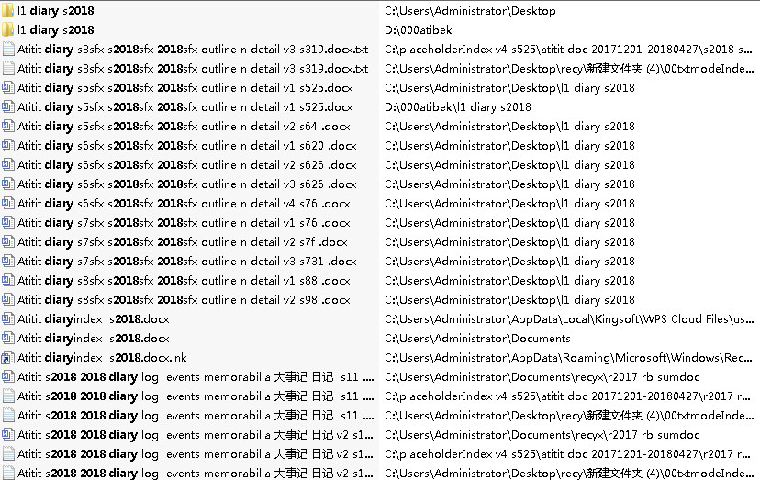

Atitit diary s9sfx s2018sfx 2018sfx outline n detail v2 s09.docx

Atitit diary s0sfx s2018sfx 2018sfx outline n detail v1 sa5.docx